Jon Brodziak - NOAA Federal, 8:39 AM
Hi Matthew, I put together a brief study for Pacific hake based on the age composition data from 2 fleets Kelli provided yesterday. Would you like to discuss this? I uploaded some results last night to repository but made some more definitive runs today over a range of scaling parameter values.
Matthew Supernaw - NOAA Federal, 8:41 AM
cool, thanks Jon! I looked over the results this morning! I'm about to pick kids up from school and drop them off at there mothers! I'll ping as soon as i get back!

The scaling parameter is the "theta" parameter in Thorson's paper. I ran the hake simulations using theta values of 0.1, 1, and 10, ranging from low signal to high signal for the Dirichlet-multinomial distribution. Hake composition data were combined into 3 age groups based on the age cuts that produced the minimal variability about a rolling mean (moving average of 3 or 5 years). Various measures of variability were used for comparison (Stdev, IQR, MAD, Variance of residual group average versus rolling mean). Hake age groupings were group 1 (ages 1-7, young fish), group 2 (ages 8-11, middle aged fish), and group 3 (ages 12-15, old fish). I used the maximum percentage of hake abundance in the composition data observed over all years to set a range of proportions to include in the simplex for the estimation process. These were 97% for group 1, 59% for group 2 and 21% for group 3. This parameter space makes biological and statistical sense as it reflects declining abundance at older ages and the reasonably good catchability across ages for the acoustic and trawl sampling.

Here's a plot of the variability metrics for fleet 1 which is the vast majority of the age composition data
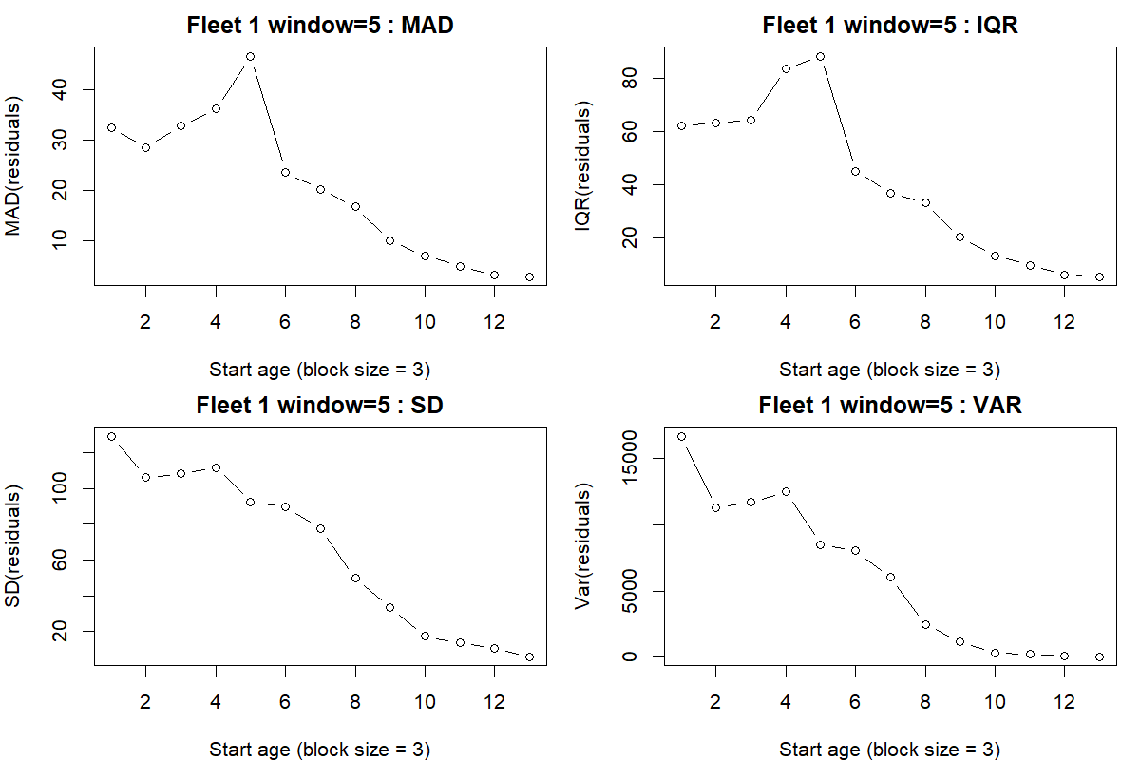

Here's a plot of the RMSE surface for the DM linear scaling parameterization (model iii) with 1000 simulations for each point with a moderate signal (theta=1) using the proportion filter by age group
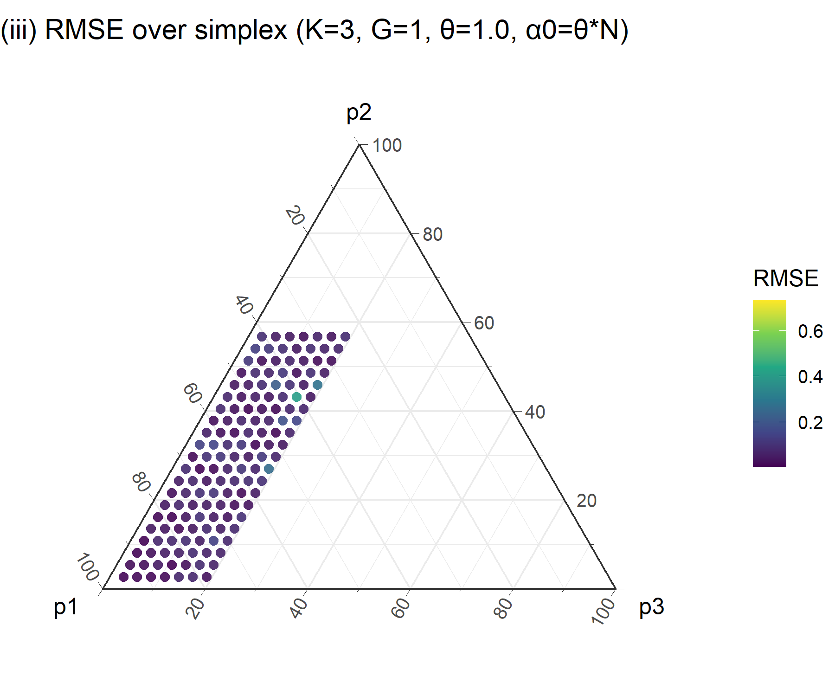
The ternary plot is read as: p1 = ages 1-7 going from 100% on bottom left to 0% top, p2 = ages 8-11 going from 100% top to 0% bottom right and p3 = ages 12-15 going from 100% bottom right to 0% bottom left.
Here's the same plot for the saturated Dirichlet multinomial (model ii)
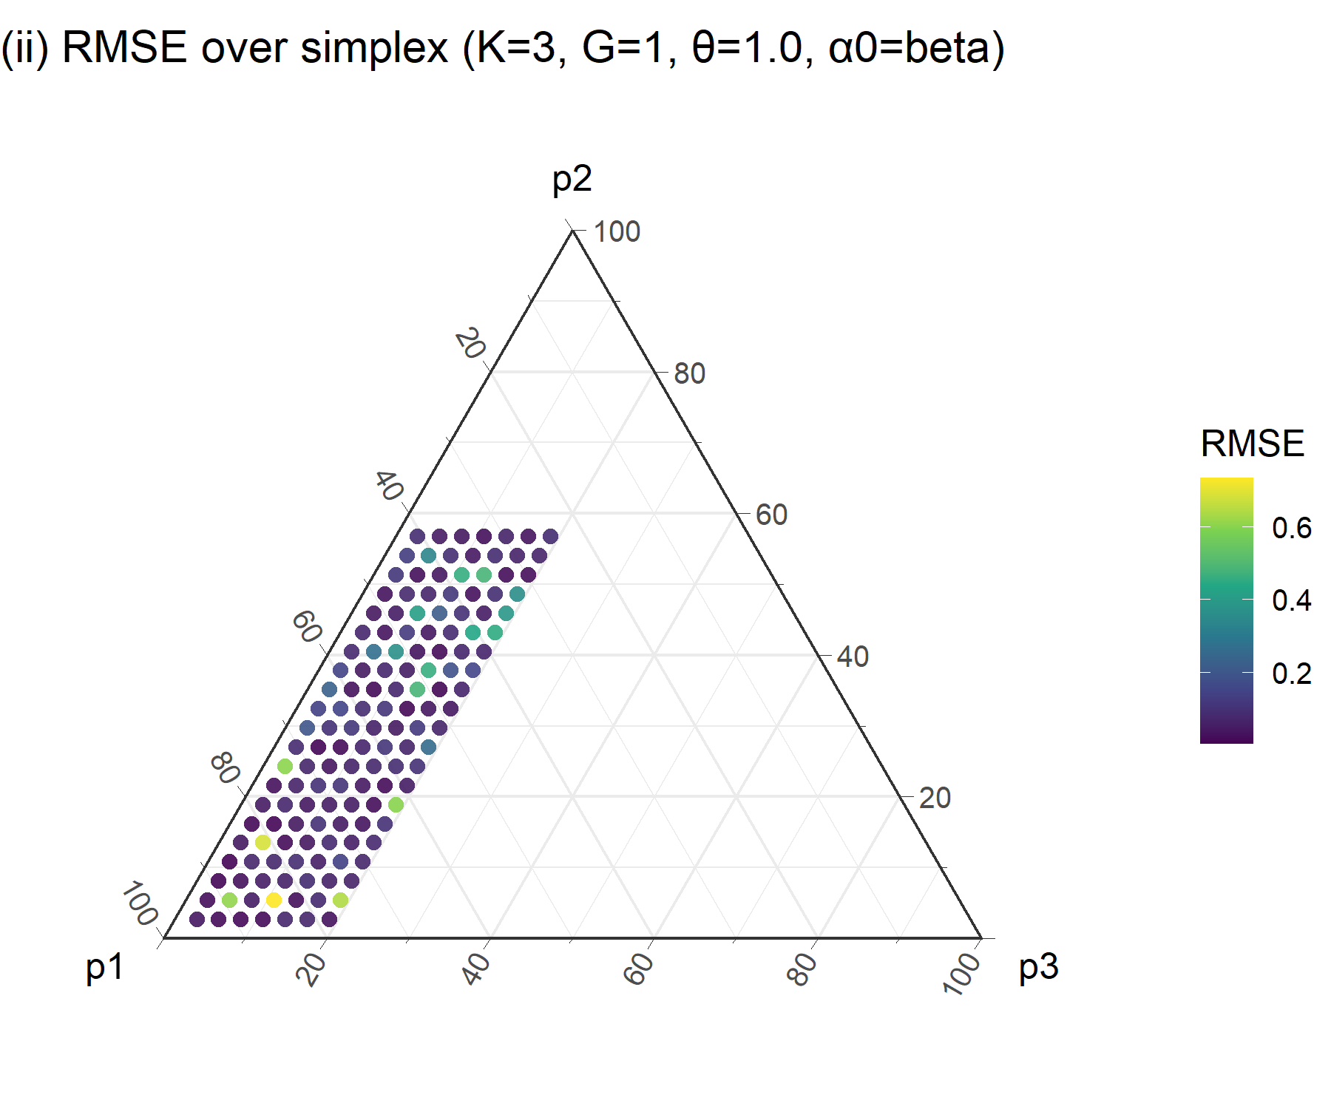
And here's the same plot for the multinomial (model iv)
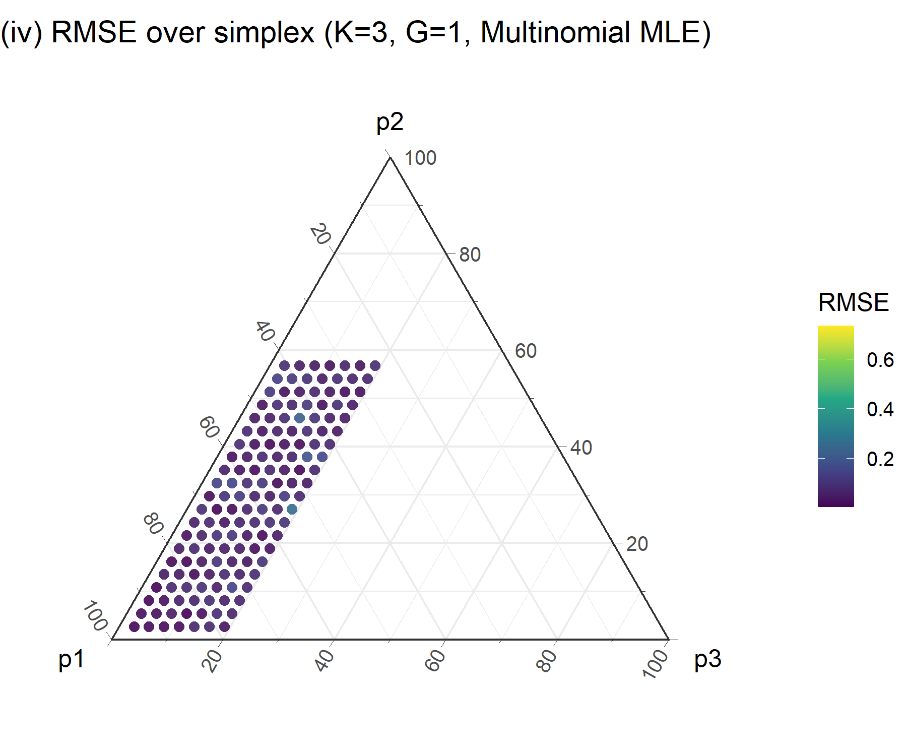
Matthew Supernaw - NOAA Federal, 9:13 AM
So, multinomial is more stable? Am I reading that right?

Yes, the multinomial is stable relative to the others (i)-(iii). The linear DM (iii) and the multinomial (iv) produce very similar performance with perhaps a slight edge to the DM (iii), based on the hypothesis tests. The dimensionality of the proportion parameter space used for (iii) and (iv) is K-1 versus K for the DM (i) and (ii). This set of simulation results relies on a scalar reduction in the total concentration parameter used to simulate the observed compositions, which is a simple way to include extra-variation/overdispersion in the data to be fitted. I have a two-stage process that induces more overdispersion but did not have time to set up the simulations for that yet. I think a bottom line would be that the multinomial appears to be a good model choice. The linear DM (iii) is also a good choice for hake but you either need to fix it or put a strong prior on theta if you want to estimate it (effectively setting the dimension to K-1).

Or, in brief, there is no evidence to rank the linear DM (iii) vs the multinomial (iv).

Matthew Supernaw - NOAA Federal, 17 min
sweet! Do you mind sending this conclusion to Kelli? She was hoping to get something today and I think you delivered!

Yes, I'll send Kelli the chat and note that I've uploaded results folders in DirichletStudy/R/hake as ageblock_analyses and run3. I'll add some readme information to the folders later today.

